- Walk-in registers too need to have billing system – before it gets registered and a Token is generated. Currently – it just simply saves and registers token for the patient
- In the patient page – if I click on “Walk-in” or “Schedule appointment” from any patient profile – the patient name should be pre-filled in this case. And once clicked on “Register Walk-in and generate token” or “schedule appointment” – the billing window will pop up as in case of consultation page.
- Once a token is generated for Walk-in Patients – in the appintments page it should not directly move the status to “With Doctor” rather it should be the same as for scheduled appointments
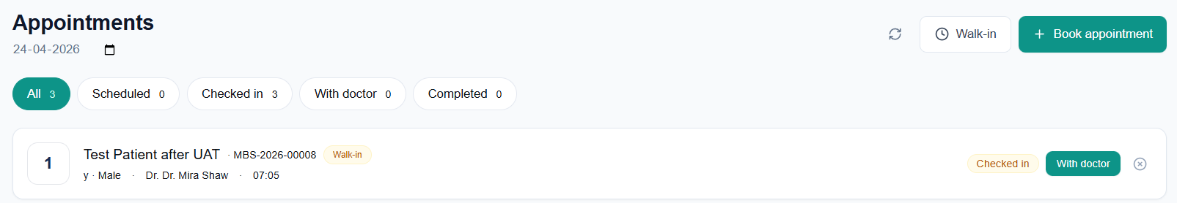
NOTE: In no scenarios a Token will be generated before billing is done
- Start Consultation failed – unknown reason. Error message appears “A record with this appointment already exists”
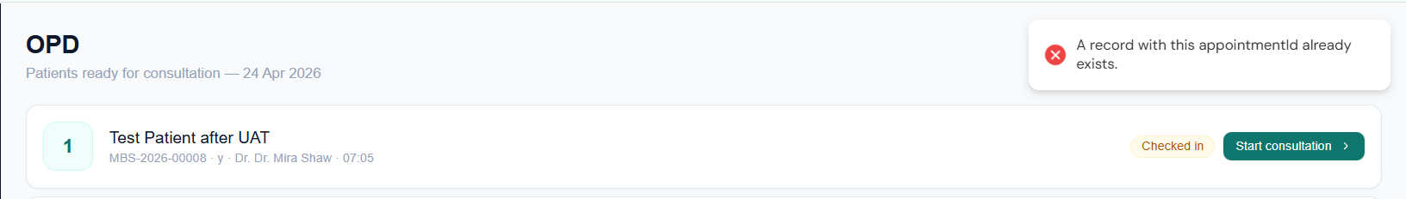

- While booking an appointment the selected doctor’s time slot should be reflected and in case the doctor is not available on the selected date – message “No Slots available” to be shown. Currently there is an issue – the “Confirm” button is disabled even on the dates the doctor is available
